Notes on the Weapons and Accouterments - Company A, 2nd Mississippi Infantry____
Dave Hunter

Continuing the tradition established at the Battle of Buena Vista, the Mississippi volunteers organized themselves into self-styled rifle companies and overwhelmingly desired to be equipped with the M1841 Rifle, widely called the “Mississippi Rifle” after the Mexican War. W.L. Sykes, the Adjutant General of Mississippi, noted this popularity in his annual report for 1860:
This arm being renowned for the brilliant victories achieved upon the battle fields of Mexico, in the hands of the First Regiment of Mississippi Riflemen, has derived the appellation of “Mississippi Rifle,” and is the principal arm called for by the Volunteer corps.

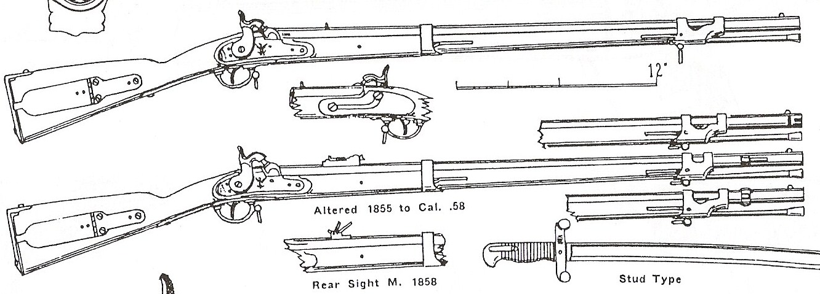
U. S Rifle, Model 1841, Cal .54

There were two models of U.S. issue rifles available in 1861. The original Model 1841 was .54 caliber, had a non-adjustable sight and did not mount a bayonet. In 1855, the Army adopted the M1855 rifle with a saber bayonet for light infantry use, which was called a “long range rifle” at the time. It should be noted here that very few people other than Ordnance officers, gun manufacturers and other Army officers would have been familiar with the various model designations of U.S. small arms. In many cases, the rifle was referred to by the volunteers by the manufacturer’s name or location stamped on the lock plate, such as a “Harpers Ferry rifle” or a “Herkimer rifle.” The term “long range rifle” came to include the later modified M1841 rifles.

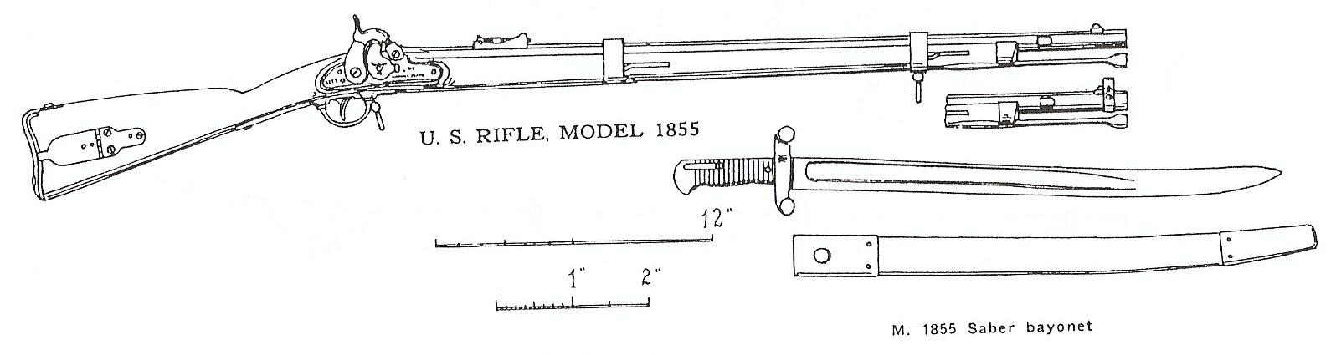
Concurrent with the adoption of the M1855 series of weapons, the Secretary of War ordered that the M1841 rifles be modified to the 1855 standard. The altered M1841 rifle was bored out to .58 caliber, provided with an adjustable sight, a new ramrod and was fitted with a lug to accept a saber bayonet, which also required the rifle to have a shortened front band. Beginning in 1855 and continuing through 1857, the Harpers Ferry Arsenal converted the M1841 rifles to the updated model. Several civilian gun makers would later obtain contracts to convert 1841 rifles, but this would occur after the war commenced. There were different patterns of sights, bayonet mountings and bayonets developed and used at Harpers Ferry and by the civilian manufacturers.

U. S Rifle, Model 1841, Altered in 1855

In March 1861 the Military Board directed that the M1841 rifle would be the basic arm of the infantry of the Army of Mississippi.

“5th Ordered, That the arm known as the Mississippi Rifle, with the Sabre Bayonet, be adopted for the Infantry of Mississippi, and the same will be furnished, as far as practicable, to all foot companies…”

The Board also specified the tactical manual to be used for Mississippi infantry and how the rifles would be used:

“6th Ordered, That “Hardee’s Light Infantry Tactics,” be adopted for Infantry and Riflemen, except that no other method of firing shall be used than that of firing by file or at will…and that one hundred copies of Light Infantry Tactics…be purchased for the purpose of distribution among the officers of the Army.”

Despite the obvious choice of the “Mississippi Rifle” for its troops, the state was ill-provided to supply them. The adjutant general reported in January 1861 that the “…impossibility of procuring the Mississippi Rifle, with sabre bayonet, has produce much dissatisfaction among the companies, and while it has caused the disbandment of some, prevented the organization of others and has, therefore, been prejudicial in two distinct ways.” He continued by saying that “…every effort has been made to procure them within the power of this Department.”
As with all the states, Mississippi drew a supply of arms yearly from the U.S. Army under the provisions of the Militia Act of 1808. The rifles provided to the states by the Militia Act of 1808 were made by civilian gun makers under government contract, and not made by the government arsenals. The vast majority of the M1841 rifles available in the southern states by 1861 were the original .54 caliber type. According to U.S Army ordnance records, Mississippi had received the following M1841 rifles prior to secession:

Brought back from Mexican War service | 365
September 1 1849 | 309
February 13, 1852 | 60
March 2, 1852 | 250
April 20, 1854 | 100
February 20, 1857 | 105
March 17, 1858 (probably rifles altered to .58 caliber) | 323
January 14, 1860 (probably the M1855 rifles actually delivered in May 1860) | 212
Total Rifles | 1724

The state had received 313 M1819 Hall flintlock breech loading rifles prior to the Mexican War, but these are not accounted for in Adjutant General Sykes’ report.
The state had constructed an arsenal in Jackson to store the weapons not distributed to the militia or volunteer companies throughout the state. However, unlike most of the other southern states, there was no Federal arsenal in Mississippi which might provide additional weapons. Attempts to purchase weapons - chiefly M1841 Rifles - in the north in May 1860 were largely unsuccessful. A shipment of sixty rifles from Eli Whitney proved to be old rifles in poor condition, refitted to the 1855 standard and the state declined to accept any more of them. The U.S. War Department shipped the Militia Act quota for 1861, 212 M1855 rifles with saber bayonets, to the state in May 1860, earlier that usually permitted. Also, the state was able to purchase 5000 converted muskets stored in the Baton Rouge Arsenal from the U.S. government.
By the end of 1860, the Volunteer Militia companies had been issued the following weapons: 1,256 M1841 and M1855 rifles; 391 M1842 or converted muskets, 60 flintlock muskets along with a quantity of sabers and single-shot pistols. The state arsenal contained the 5000 percussion conversion muskets, some flintlock muskets and some older accouterments.
After the seizure of the Baton Rouge Arsenal by Louisiana forces in January 1861, Governor Pettus requested some of the weapons stored there and Louisiana provided them. Mississippi received 5000 flintlock muskets, 3000 percussion muskets, 1000 Hall rifles, ammunition and six pieces of artillery. (The Hall rifles were flintlocks and required conversion to percussion, which was not completed in Mississippi until August, 1861)
Therefore, the “Army of Mississippi” would go to war with far fewer Mississippi Rifles than were needed. In January 1861, the Adjutant General listed the weapons and accouterment in the hands of the Volunteer companies as part of his annual report. There are three categories of rifles listed on the report: “U.S. Longrange Rifl’s” [U.S. Long Range Rifles], “Percussion Rifles” and “Altered Percus. Rifl’s” [Altered Percussion Rifles]. Interestingly, none of the ordnance reports listed by the Adjutant General in his 1860 report describe any rifles as “Mississippi Rifles.” Below is the assignment of rifles to the infantry or rifle companies:

U.S. Long Range Rifles | 5 companies
Percussion Rifles | 14 companies
Altered Percussion Rifles | 4 companies
Saber Bayonets | 5 companies with U.S. Long Range Rifles  7 companies with Percussion Rifles

Saber bayonets were issued to the five companies with U.S. Long Range Rifles and to seven of the companies with Percussion Rifles. This would indicate that the U.S. Long Range Rifles were the M1855 rifles, and the Percussion Rifles that would accept saber bayonets were the M1841 rifles converted to .58 caliber. The remaining Percussion Rifles were the older .54 caliber M1841 rifles.
The “Altered Percussion Rifles” would have to be the M1814 or M1817 “common rifles” converted to percussion. The adjutant general’s report refers to the 5000 percussion conversion muskets from the Baton Rouge Arsenal as “Altered percussion muskets”, so it is logical to assume that the “altered percussion rifles” are the percussion conversions of the M1814 or M1817 rifle.
Augustus Vaiden, the Orderly Sergeant for the “O’Connor Rifles”, recorded an interesting comment on their weapons in his diary on June 29, 1861.

… At 4 PM the regt. assembled & discharged the guns at a target at 100 yards, 65 shots per company. Tishomingo Rifles together with Iuka Rifles (muskets) put most balls in target, 5 balls striking. The O'Connor Rifles, however, done the best shooting generally, having Derenger (Mississippi) Rifles. The target was 6 feet high by 2 wide.

The comment on “Derenger” rifles provides a hint on the type of rifles used in Company B. Henry Deringer, a small arms manufacturer and government contractor, did not produce any M1841 rifles. Deringer did produce a small number of Model 1814 rifles but a much larger number of Model 1817 rifles through four contracts with the War Department between 1819 and 1840. These were .54 caliber flintlock rifles, known at the time as “common rifles.” Given the numbers Deringer produced, the rifles in Company B were most likely the M1817 type. Deringer produced a very small number of M1817 rifles with percussion locks, but none were purchased by the Army. The January 1861 report showed the company to have 80 “Altered Percus. Rifl’s”, which would indicate the use of the M1817 rifles, converted to percussion and not Mississippi Rifles. (The M1817 rifles would have been part of the Militia Act issues prior to the Mexican War.)
There are no indications in the adjutant general’s report that Mississippi planned to convert any of its .54 caliber rifles to mount saber bayonets in 1861. Also, the .54 caliber rifles probably did not receive the lug clamps to permit use of saber bayonets prior to early 1862, when the first issues of Confederate-made saber bayonets reached the Army of Virginia. (The lug clamps were not patented until September 1861 by Boyle, Gamble and McFee of Richmond.)
While some of the Mississippians would be carrying the U.S. Army’s latest weapon, not all were satisfied with it. One of them described the M1855 rifle in the Yazoo Democrat, on August 4, 1860:
The Bayonet Rifle.—We have had the pleasure of examining a sample of the rifles with bayonets, ordered by our State for the volunteer militia. The gun differs from the rifle now in use in the following respects: Length is about the same,--bore considerably larger, consequently barrel not so thick,--mounted with iron, and stock not as neatly finished. The sword bayonet which is protected by a scabbard, is so constructed that by application of the thumb to a spring it can be separated from the gun, and having a handle and guard like a cutlass, can be used as a sword or cutlass when in close contact. The sights are variable at will, for any distance within the range of the rifle.
These are all the variations, of any note, from the Mississippi Rifle. They may all be improvements in the art of warfare, yet we are at a loss to discover the advantages to be derived from an increase in the size of the ball.—Mississippian.

While the majority of the volunteers desired to be riflemen, the shortage of rifles would require many to carry muskets. Orderly Sergeant Vaiden of the O’Connor Rifles noted on May 2, 1861 that “We cannot be furnished with arms & uniforms as we expected except the 50 we brought with us. All the other companies are in the same fix, nevertheless we will go on.” Faced with this shortage of rifles, the initial Mississippi infantry regiments were organized following the US Army regimental structure used in the Mexican War period. Two companies were designated as “flank” companies and were armed with rifles. The remaining eight companies were armed with muskets. (This type of regimental organization had been rendered obsolete with the adoption of Hardee’s Tactics and the M1855 series weapons. With the new tactics, all companies were trained to act as light infantry.) In the 2nd Mississippi, Company A, the “Tishomingo Riflemen” and Company B, the “O’Connor Rifles,” were the flank companies and retained their rifles.
The Tishomingo Riflemen had been issued 40 “U.S. Longrange Rifl’s”, along with 40 saber bayonets and scabbards. These rifles were most likely M1855 rifles. The photograph of Pvt. Parish of the Tishomingo Riflemen shows him holding a saber bayonet for the M1855 rifle. The altered Mississippi Rifles were issued with three different patterns of saber bayonet, none of which were the same as the M1855 pattern.

ACCOUTERMENTS

In March, 1860 Adjutant General Sykes directed that the older arms and accouterments, which he called a “pile of rubbish”, be “overhauled, and examined, cleaned and stored away for and emergency.” In January 1861, he listed the following items as “in tolerable order and fit for use.”

229 | Bayonet scabbards
315 | Cartridge Boxes, pistol and musket
214 | Rifle, Pouch, and flask belts
56 | Waist belts
106 | Saber belts
107 | Saber knots
119 | Gun slings
276 | Dragoon shoulder belts
60 | Holsters
116 | Rifle pouches
88 | Powder Flasks
160 | Flintlock muskets, browned barrel
72 | Flintlock muskets, bright barrel
106 | Sabers

The Adjutant General added that there were “about one hundred and fifty stand of percussion rifles” due to be returned from three disbanded companies of volunteers. The report also noted that “Most of the cartridge boxes, sabres, belts, holsters, pouches, flasks, &c., &c., have been distributed.” A contract for accouterments with Ames Manufacturing Company from June 1860 was not completed before secession and only 500 of the 1700 sets ordered were delivered.
The prescribed sword belt for officers was to be of “black leather, plain or enameled” with a “plain clasp of gilt or brass.” Lt. Davenport (Company A) is shown wearing this type of belt. Sword belts for enlisted men were to be “black leather, plain” with a “plain brass buckle”. Perhaps this indicates that all other belts and accouterments were to be black leather as well.
There were commercially available belt plates for Mississippi which show an eagle design. These were available as an oval belt plate and cartridge box plate and an U.S. 1851 style rectangular sword belt plate. Sydney C. Kerksis describes all of these plates as “very rare and seldom seen.” The similarity of this eagle design, actually the Mississippi state seal, to the Federal eagle prompted a change in the belt plates after secession. Plain rectangular plates with a large five-pointed star, either die-stamped or a separate piece fixed to the plate were a little more common among Mississippi troops. Round “wreath and spoon” buckles with this large star are also attributed to Mississippi troops.
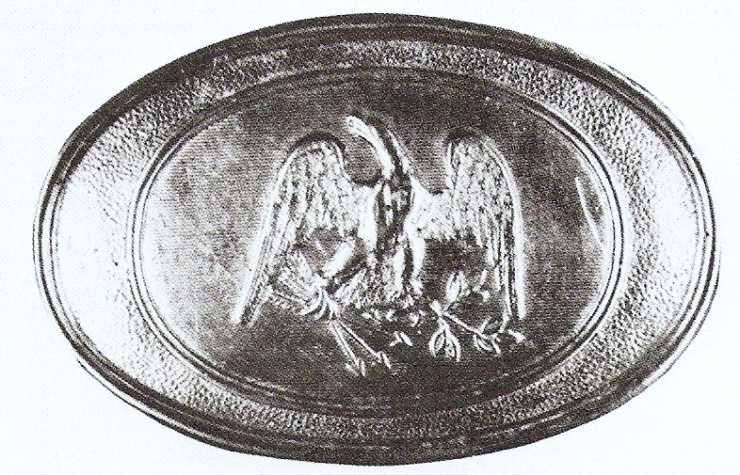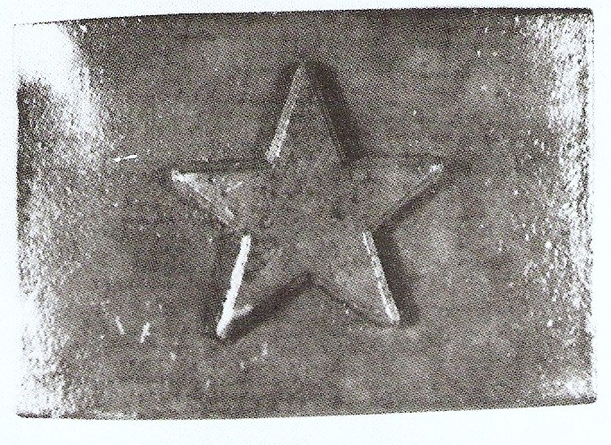

There is a well known photograph of Mississippi troops in Pensacola in 1861 showing US Army accouterments is use. The men depicted are from Company B, 9th Mississippi and two are shown with M1855 rifles and wearing their accouterments, less their cap pouches. This company, the “Home Guards” from Marshall County, were issued fifty M1855 rifles (“U.S Longrange Rifl’s”) but only 40 sets of accouterments in 1860. This image clearly shows that the leather belting was black. If the 1839 pattern white buff belts were issued, they were obviously blackened.

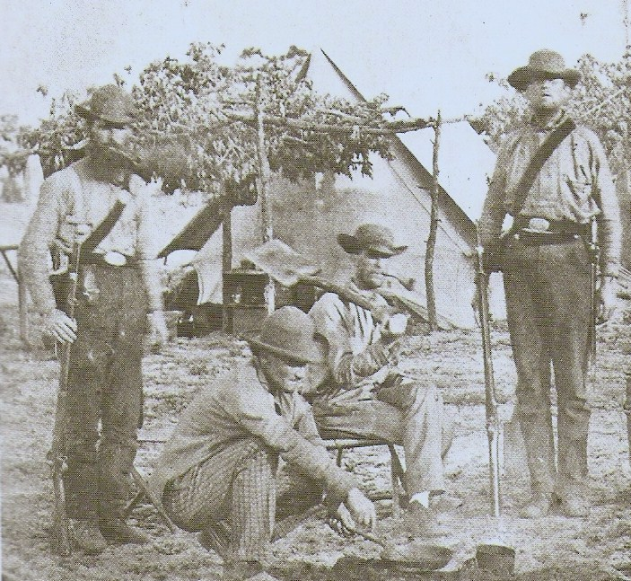
Mississippi Riflemen - Soldiers of Company B, 9th Mississippi, 1861, armed with M1855 rifles and US accouterments.
The Tishomingo Riflemen received 40 cartridge boxes and plates, 40 cartridge box belts, 40 cap pouches, 40 waist belts and plates, along with four M1840 NCO swords and belts in 1860. The cartridge box belts issued would suggest that the company was not issued the 1839 pattern rifle cartridge box, which had no provision for a shoulder belt. These accouterment sets could be either the US 1857 pattern boxes and belts or the earlier 1839 patterns. The 1855 pattern belt for riflemen did not have a “plate” so these probably were not issued to the company.

Weapons and Accouterments for First Manassas

Clearly, we should be carrying M1855 rifles for this event, but that will not be possible. The next choice would be either type of the M1841 rifle, but few of us have them. Those that can borrow one for this event are encouraged to do so. The rest of us should carry M1842 muskets, as we have these available, and Mississippi troops used them in 1861. P1853 Enfield rifle muskets are permitted, but discouraged. Try to borrow a rifle or an 1842 musket. Ammunition should be packaged in plain wrappers.
We know that the Tishomingo Riflemen were issued some sets of US pattern accouterments prior to the war. These were probably the 1857 pattern sets or the earlier M1839 pattern sets, with the white buff leather blackened. If you have US accouterments that meet these requirements, then use them. If you don’t have Federal accouterments, then use your CS box, box sling, cap box and scabbard. With this, you can use a US waist belt, a Mississippi belt and plate, or your NC harness buckle belt.
During this period, there were still individual soldiers carrying large side knives or fighting knives of some sort. The Bowie knife figured large in the Mexican War image of Mississippians, so the next generation would continue the tradition. The patterns of these knives varied as much the men that carried them, but the large Bowie-style knife appeared to be the favorite. If you choose to carry one of these for First Manassas, it should be a style seen on Mississippi troops at that time. Based on several images, one style that was popular was the smaller “commercial” bowie knife, usually imported from Sheffield, England.

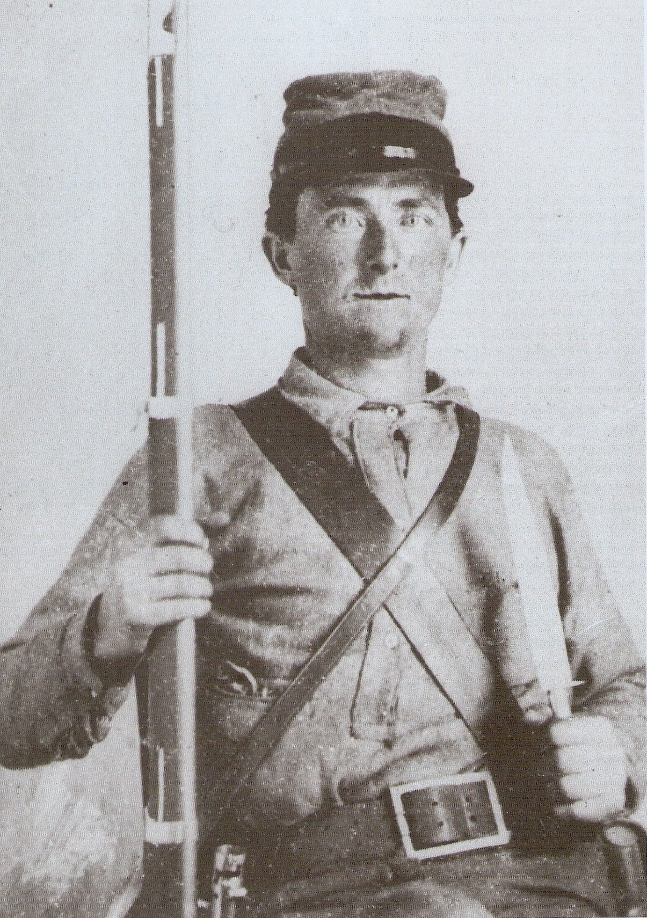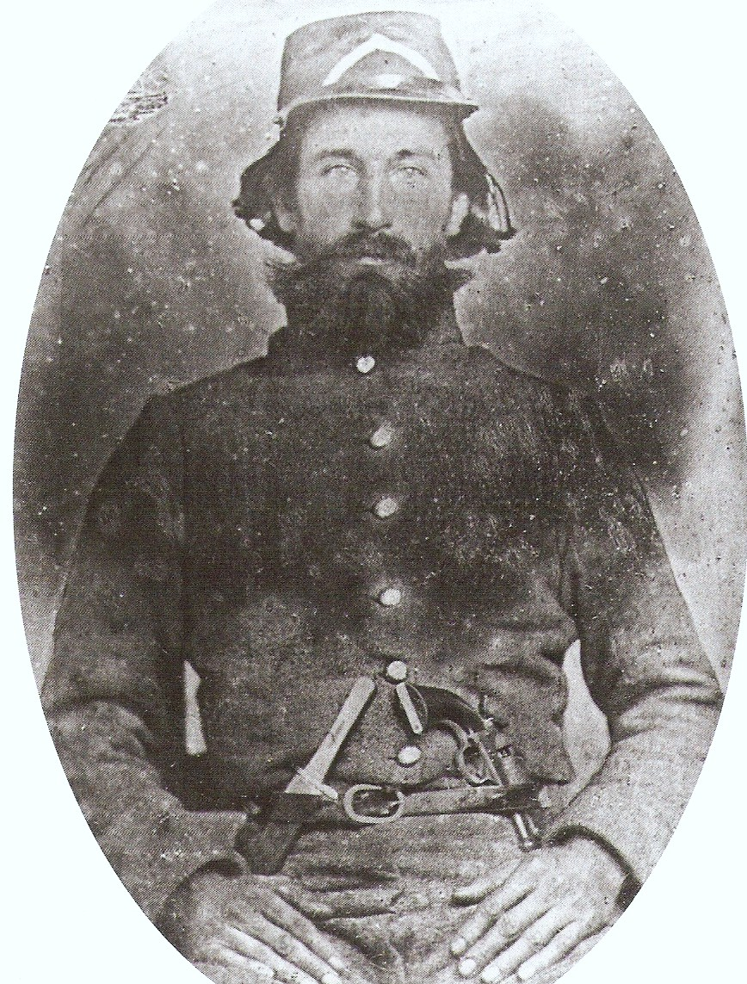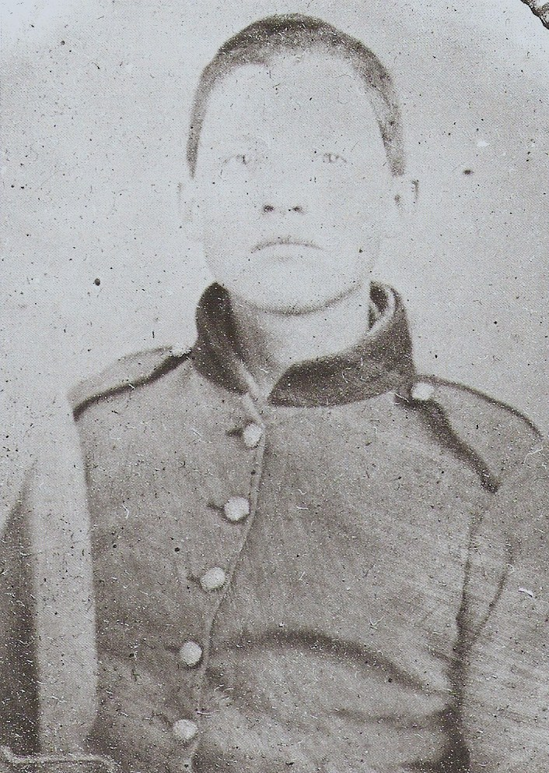
Typical knives carried by Mississippi soldiers, 1861-62. The “commercial” knife is at left and center, with a larger locally made knife on the right.

Pistols were also considered essential for close combat by most volunteers. The general scarcity of these weapons and the resulting high cost kept many from obtaining a handgun. Still, we see Mississippians with them, either their own pistol or a photographer’s prop. If you chose to carry one, it should be of a type common in the state in 1861: Colt, Whitney, or some single-shot pocket pistol. No Confederate manufactured revolvers (brass framed Colt copies, Spiller and Burr, etc.) are permitted, as these were not available prior to First Manassas.
Notes on Sources

The details on weapons and accouterments available and issued to Mississippi volunteer companies is found in the Annual Report of the Adjutant General of the State of Mississippi, January 18, 1861, and Frederick P. Todd, American Military Equipage 1851-1872, Volume II, State Forces, Chapter XXXVIII. The orders to issue M1841 rifles and the use of Hardee’s Tactics are from Orders of the Military Board of the State of Mississippi (Jackson: E. Barksdale, State Printer, 1861) reprinted in Sydney C. Kerksis, Plates and Buckles of the American Military, 1795-1874. The photographs of the Mississippi belt plates are from the Kerksis book.
The information on the M1841 and M1855 rifles is from Robert M. Reilly, United States Military Small Arms, 1816-1865. The list of M1841 rifles issued to the State of Mississippi came from John M. Murphy and Howard M. Madaus, Confederate Rifles and Muskets: Infantry Small Arms Manufactured in the Southern Confederacy 1861-1865, which discussed the distribution of these weapons prior to the war. Murphy and Madaus also detail the early issues of saber bayonets for the standard model M1841 rifles in CS service. The illustrations of the M1841 and M1855 rifles are from James A. Hicks, US Military Firearms 1775-1956. One M1841 rifle thought to be part of the 1860 Whitney contract is shown in Richard T. Hill and William G. Anthony, Confederate Longarms and Pistols: a Pictorial Study.
The photographs of the two riflemen from Co. B, 9th Mississippi and Pvt. Farmer, along with the knife-wielding Mississippians, are from B. Roberts and C. Moneyhon, Portraits of Conflict: a Photographic History of Mississippi in the Civil War. The Mississippi SCV website provided information on the organization of the 9th Mississippi Infantry. The newspaper information is found on Vicki Betts’ “Civil War Newspapers” website. Details on antebellum US Army infantry regiment organization is from the Army Lineage Series, Infantry, Part I: Regular Army, John K. Mahon and Romana Danysh.

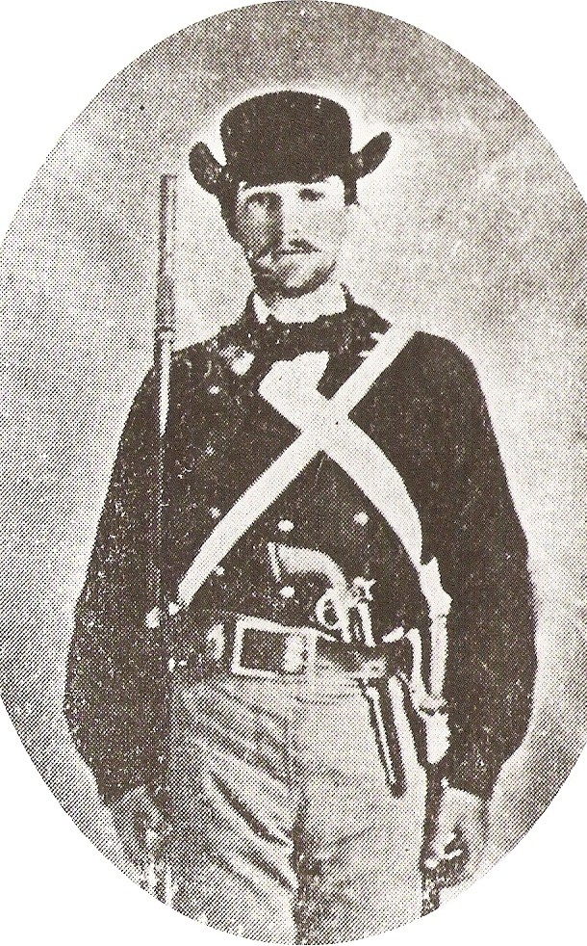
A Mississippi Rifleman. Pvt. Dewitt C. Farmer of the Noxubee Rifles with a “Percussion Rifle”, Model 1841. This company was provided saber bayonets in 1860 and Pvt. Farmer appears to be carrying his in a white buff leather frog. However, his rifle seems to lack a bayonet lug.
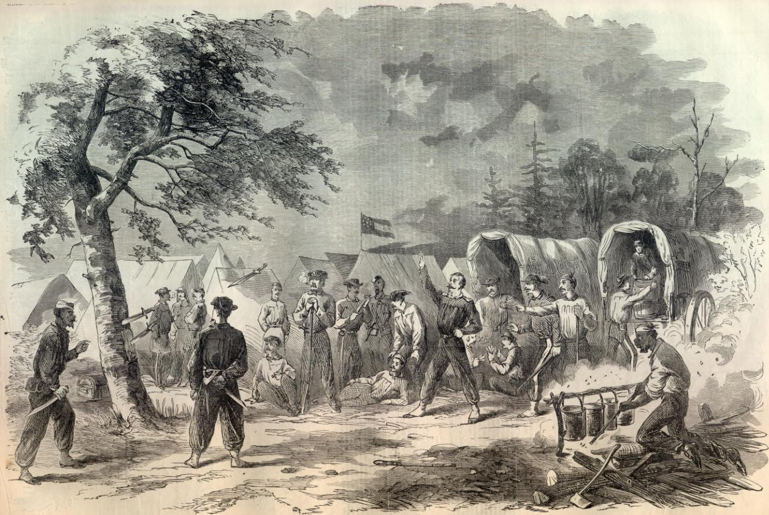

“Get the biggest knife you can find…” Mississippi riflemen practicing with their Bowie knives, from Harper’s Weekly, 1861

